## DAYANANDA SAGAR UNIVERSITY

**KUDLU GATE, BANGALORE – 560068**



**Bachelor of Technology**

**COMPUTER SCIENCE AND ENGINEERING (ARTIFICIAL INTELLIGENCE & MACHINE LEARNING)**

**UG Research Project – I (22AM2305)**

**AI POWERED MOUSE**

**(1. with eye movement**

**2. with hand gestures movement.)**

By:

**NAME: PRAJWAL B USN: ENG22AM0038**

**NAME: PRAVEEN POSA S USN: ENG22AM0040**

**NAME: DEVANAGOUDA USN: ENG22AM0011**

**NAME: PRATIK KALKATTI USN: ENG22AM0039**

Under the supervision of

**Prof. PRADEEP KUMAR K, Prof.Mary Jasmine.E, Prof.Mitha Guru**

**CSE (AI &ML)**

**DEPARTMENT OF COMPUTER SCIENCE & ENGINEERING (AI&ML),**

**SCHOOL OF ENGINEERING DAYANANDA SAGAR UNIVERSITY,BANGALORE**

**(2023-2024)**



**Dayananda Sagar University**

**School of Engineering**

**Department of Computer Science & Engineering (Artificial Intelligence & Machine Learning)**

**Kudlu Gate, Bangalore – 560068 Karnataka, India**

## CERTIFICATE

This is to certify that the UG mini project– I (22AM2305) work titled **“AI POWERED MOUSE WITH EYE MOVEMENT AND HAND MOVEMENT”** is carried out by **Prajwal B** bearing **USN: ENG22AM0038, Praveen Posa S** bearing **USN: ENG22AM0040 Pratik Kalkatti** bearing **USN: ENG22AM0039, Devan gouda** bearing **USN :ENG22AM0011** Bonafede student of Bachelor of Technology in Computer Science and Engineering (AI&ML) at the School of Engineering, Dayananda Sagar University, Bangalore in partial fulfillment for the award of degree in Bachelor of Technology in Computer Science and Engineering, during the year **2023-2024**.

|  |  |  |
| --- | --- | --- |
| Prof. Pradeep Kumar K Assistant Professor  Dept. of CS&E (AI&ML), School of Engineering  Dayananda Sagar University  Date: 29-11-2023 | Dr. Jayavrinda Vrindavanam V Chairman CSE (AI&ML) School of Engineering  Dayananda Sagar University Date: 29-11-2023 | Dr. Udaya Kumar Reddy K R Dean  School of Engineering  Dayananda Sagar University Date: 29-11-2023 |

## DECLARATION

We**, Prajwal B, Praveen Posa s, Devan Gouda, Pratik KalKatti** students of third semester

B. Tech in **Computer Science and Engineering with speciation in Artificial intelligence and machine learning** , at School of Engineering, **Dayananda Sagar University**, hereby declare that the **UG Research Project -I** titled **“AI POWERED MOUSE”** hasbeen carried out by us and submitted in partial fulfilment for the award of degree in **Bachelor of Technology in Computer Science and Engineering** during the academic year **2023-2024**.

**Student Signature**

**Name: Prajwal B USN: ENG22AM0038**

**Name: Praveen Posa S USN: ENG22AM0040**

**Name: Devan Gouda USN: ENG22AM0011**

**Name: Pratik Kalkatti USN: ENG22AM0039**

**Place: Bangalore Date: 05 - 12 - 2023**

## TABLE OF CONTENTS

ABSTRACT 5

INTRODUCTION 6-9

LITERATURE SURVEY------------------------------- 10-11

PROBLEM DEFINITION------------------------------ 12

METHODOLOGY--------------------------------------- 13-18

RESULT AND ANALYSIS----------------------------- 19-23

CONCLUSION 24-25

REFERENCES 26

## ABSTRACT

The mouse is one of the wonderful inventions of Human-Computer Interaction (HCI) technology. Currently, wireless mouse or a Bluetooth mouse still uses devices and is not free of devices completely since it uses a battery for power and a dongle to connect it to the PC. In the proposed AI virtual mouse system, this limitation can be overcome by employing webcam or a built-in camera for capturing of hand gestures and hand tip detection using computer vision. The algorithm used in the system makes use of the machine learning algorithm. Based on the hand gestures, the computer can be controlled virtually and can perform left click, right click, scrolling functions, and computer cursor function without the use of the physical mouse. The algorithm is based on deep learning for detecting the hands.

**Keyword**-Human-Computer Interaction (HCI), computer vision.

In many cases, persons with neuro-locomotordisabilities have a good level of understanding and should use their eyes for communication. In this paper a reliable, mobile and low-cost system based on eye tracking mouse is presented.The eye movement is detected by a head mounted device and consequently the mouse cursor is moved on the screen. A click event denoting a pictogram selection is performed if the patient gazes a certain time the corresponding image on the screen.

**Keywords**-assistive technology, image processing, pupil detection, video glasses.

## CHAPTER 1 INTRODUCTION

With the development technologies in the areas of augmented reality and devices that we use in our daily life, these devices are becoming compact in the form of Bluetooth or wireless technologies. This paper proposes an AI virtual mouse system that makes use of the hand gestures and hand tip detection for performing mouse functions in the computer using computer vision. The main objective of the proposed system is to perform computer mouse cursor functions and scroll function using a web camera or a built-in camera in the computer instead of using a traditional mouse device. Hand gesture and hand tip detection by using computer vision is used as a HCI [1] with the computer. With the use of the AI virtual mouse system, we can track the fingertip of the hand gesture by using a built-in camera or web camera and perform the mouse cursor operations and scrolling function and also move the cursor with it.

While using a wireless or a Bluetooth mouse, some devices such as the mouse, the dongle to connect to the PC, and also, a battery to power the mouse to operate are used, but in this paper, the user uses his/her built-in camera or a webcam and uses his/her eye movement to control the computer mouse operations. In the proposed system, the web camera captures and then processes the frames that have been captured and then recognizes the various hand gestures and eye movement gestures and then performs the particular mouse function.

Python programming language is used for developing the AI virtual mouse system, and also, OpenCV which is the library for computer vision is used in the AI virtual mouse system. In the proposed AI virtual mouse system, the model makes use of the MediaPipe package for the tracking of the hands and for tracking of the tip of the hands, and also, Pynput, Autopy, and PyAutoGUI packages were used for moving around the window screen of the computer for performing functions such as left click, right click, and scrolling functions. The results of the proposed model showed very high accuracy level, and the proposed model can work very well in real-world application with the use of a CPU without the use of a GPU.

### Model

Computer vision is a rapidly evolving field that empowers machines to interpret and understand visual information, mirroring human visual perception. Leveraging artificial intelligence and image processing techniques, computer vision enables machines to analyze and extract meaningful insights from images or videos. This technology finds diverse applications, from facial recognition and object detection to medical imaging and autonomous vehicles.

Key components of computer vision include image acquisition, preprocessing, feature extraction, and pattern recognition. Convolutional Neural Networks (CNNs) have played a pivotal role in advancing image analysis, allowing machines to recognize complex patterns and hierarchical structures within visual data. Additionally, advancements in deep learning have significantly improved the accuracy and efficiency of computer vision systems.

The practical implications of computer vision are widespread, impacting industries such as healthcare, automotive, retail, and security. Facial recognition systems enhance security measures, while in medical imaging, computer vision aids in diagnosis and treatment planning. As technology continues to progress, the integration of computer vision promises to revolutionize various sectors, enhancing automation, decision-making, and overall efficiency.

### 1.2 COMPUTER VISION(OPEN CV).

Computer vision involves enabling machines to interpret and make decisions based on visual data, such as images or videos. It includes tasks like image recognition, object detection, and facial recognition, using algorithms and deep learning to mimic human vision processes.

Applications range from self-driving cars to medical image analysis.

Computer vision, a subfield of artificial intelligence, aims to empower machines with the ability to interpret and understand visual information, much like human vision. This

multidisciplinary domain merges computer science, mathematics, and neuroscience to

develop algorithms and models that enable computers to analyze and make decisions based on visual data.

At its core, computer vision strives to replicate human vision processes using computational techniques. This involves the extraction of meaningful information from images or videos, enabling machines to perceive and comprehend their surroundings. The primary goal is to endow computers with the capability to recognize patterns, objects, and scenes, fostering a deeper understanding of the visual world.

One fundamental task in computer vision is image recognition, where machines are trained to identify and categorize objects within images. This involves feeding large datasets into

algorithms that learn to recognize patterns and features associated with specific objects.

Convolutional Neural Networks (CNNs) are a prevalent architecture for image recognition, mimicking the visual processing in the human brain.

Object detection is another crucial aspect of computer vision, allowing machines to not only identify objects but also locate their positions within an image. This is pivotal for applications like autonomous vehicles, where the system must recognize and track various objects in its environment to make informed decisions.

Facial recognition, a subset of computer vision, involves identifying and verifying individuals based on their facial features. This technology has found applications in security systems,

mobile devices, and social media platforms, raising concerns about privacy and ethical considerations.

In recent years, deep learning has revolutionized computer vision by enabling the

development of sophisticated models that can automatically learn hierarchical representations of visual data. This has led to remarkable progress in tasks like image segmentation, where

machines can differentiate and outline the boundaries of distinct objects within an image.

Computer vision extends beyond static images to dynamic visual data, such as videos. Video analysis involves tasks like action recognition, where machines discern and classify human actions within a sequence of frames. This is pivotal in surveillance, sports analysis, and human-computer interaction.

Applications of computer vision are diverse and impactful. In the healthcare sector, it aids in medical image analysis, assisting in the diagnosis and treatment of various conditions. In

agriculture, computer vision facilitates crop monitoring and yield prediction. Retail industries utilize it for inventory management and customer tracking, while augmented reality leverages computer vision to overlay digital information on the real-world environment.

Despite its advancements, computer vision faces challenges such as handling occlusions, variations in lighting, and ensuring ethical use, especially in areas like surveillance and privacy. Researchers continually explore innovative approaches and refine existing

techniques to address these challenges and enhance the capabilities of computer vision systems.

In conclusion, computer vision represents a fascinating intersection of computer science and visual perception, with the potential to transform numerous industries. As technology

advances, the synergy between artificial intelligence and computer vision is expected to unlock new possibilities, paving the way for smarter, more perceptive machines.

## CHAPTER 2 LITERATURE REVIEW

**Base Paper:** Eye Tracking Mouse for Human Computer Interaction. by- Robert Lupu, Florina Ungureanu, Valentin siriteanu.

[https://www.researchgate.net/publication/261488950_Eye_tracking_mouse_for_human_com](https://www.researchgate.net/publication/261488950_Eye_tracking_mouse_for_human_computer_interaction) [puter_interaction](https://www.researchgate.net/publication/261488950_Eye_tracking_mouse_for_human_computer_interaction)

The article proposes a novel eye-tracking mouse system for people with disabilities,

addressing the limitations of existing systems. It discusses various eye-tracking methods and highlights the advantages of using video glasses and a webcam for enhanced accuracy and mobility.

Traditional eye-tracking systems often rely on dedicated hardware, making them expensive and cumbersome. The proposed system leverages readily available webcams and video

glasses, offering a more cost-effective and portable solution. Additionally, it overcomes the limitations of traditional gaze-based interaction, which can be imprecise and susceptible to fatigue.

The system operates by capturing real-time video of the user's eyes through the webcam or video glasses. Sophisticated algorithms then analyze the video data to identify and track eye movements. These movements are translated into corresponding cursor movements on the computer screen, enabling users to control the interface without physical hand movements.

A key feature of the system is its dwell-click functionality. Users can click on items by

simply focusing their gaze on them for a predetermined duration. This eliminates the need for physical button presses, making the system accessible to individuals with motor impairments.

The article emphasizes the system's accuracy and reliability compared to traditional eye-

tracking approaches. Webcam-based systems are often susceptible to environmental factors

like lighting variations, while video glasses can be occluded by hair or facial movements. The proposed system addresses these challenges by employing a hybrid approach, combining the strengths of both webcams and video glasses.

Furthermore, the system's portability makes it suitable for various environments. Unlike

traditional fixed setups, users can freely move around while using the system, enabling them to interact with computers in more dynamic settings.

The article concludes by discussing the potential applications of the proposed eye-tracking mouse system. It highlights its benefits for individuals with disabilities, enabling them to access computers and participate in digital activities more effectively. Additionally, the

system's hands-free interaction capabilities could prove advantageous in various fields, such as education, gaming, and virtual reality.

Overall, the article presents a promising new approach to eye-tracking mouse technology, addressing the limitations of existing systems and offering a more accessible and mobile

solution for human-computer interaction. The system's potential to empower individuals with disabilities and enhance interaction in diverse contexts makes it a valuable contribution to the field of assistive technology.

**Base Paper:** Eye Tracking Mouse for Human Computer Interaction. by- Robert Lupu, Florina Ungureanu, Valentin siriteanu.

[https://www.researchgate.net/publication/261488950_Eye_tracking_mouse_for_human_com](https://www.researchgate.net/publication/261488950_Eye_tracking_mouse_for_human_computer_interaction) [puter_interaction](https://www.researchgate.net/publication/261488950_Eye_tracking_mouse_for_human_computer_interaction)

The Al Virtual Mouse uses computer vision techniques to track hand movements and

translates them into cursor movements on the screen. The system is designed to be intuitive and user-friendly, allowing users to interact with their computer without the need for a

physical mouse. The virtual mouse is developed using Python and OpenCV libraries. The project includes the implementation of various image processing algorithms, such as hand

segmentation, feature extraction, and classification. Moreover, it is robust to various lighting conditions, backgrounds, and hand sizes. The developed system provides an alternative to

conventional mouse devices, particularly for individuals with disabilities or those who prefer a more natural way of interacting with their computers. The target of this project is the invention of something new in the world of technology that helps an individual work without the help of a physical mouse. It will save the user money and time. Real-time images will be continuously collected by the Virtual Mouse color recognition program and put through a number of filters and conversions. When the procedure is finished, the program will use an

image processing technique to extract the coordinates for the position of the desired colors from the converted frames. The virtual mouse system is evaluated on various metrics, such as accuracy, speed, and robustness, and compared with existing virtual mouse systems. The trial findings demonstrated a high degree of accuracy 97.37%; the system can operate well in

actual scenarios with just one CPU. Following that, it will compare the current color schemes within the frames to a list of color combinations, where various combinations correspond to various mouse operations. If the current color scheme matches, the program will execute a mouse command, which will be converted into a real mouse command on the user's

computer.

## CHAPTER 3

## PROBLEM DEFINITION

Designing an AI-powered mouse utilizing eye movement for enhanced user interaction and accessibility. The system should accurately track and interpret eye movements to control the cursor, click, and perform other mouse functions seamlessly. Challenges include developing robust eye-tracking algorithms, ensuring real-time responsiveness, and addressing potential user discomfort. Additionally, considerations for adaptability to diverse eye conditions and optimizing the user interface for intuitive control must be incorporated into the solution.

Design and implement an AI-powered mouse system that utilizes hand gestures for intuitive and hands-free computer interaction. The system should accurately interpret a diverse range of hand movements and gestures, providing users with a seamless and efficient alternative to traditional mouse input methods. Key challenges include real-time gesture recognition, robust tracking in varying environmental conditions, and ensuring a user-friendly experience with

minimal false positives or negatives. Additionally, the system should consider accessibility, adaptability to different applications, and overall user satisfaction in order to enhance the

overall human-computer interaction experience.

## CHAPTER 4

## METHODOLOGY

The various functions and conditions used in the system are explained in the flowchart of the real-time AI virtual mouse system in Camera Used in the AI Virtual Mouse System. The proposed AI virtual mouse system is based on the frames that have been captured by the webcam in a laptop or PC. By using the Python computer vision library OpenCV, the video capture object is created and the web camera will start capturing video. The web camera captures and passes the frames to the AI virtual system. Capturing the Video and Processing. The AI virtual mouse system uses the webcam where each frame is captured till the termination of the program. The video frames are processed from BGR to RGB colour space to find the hands in the video frame by frame

**Software Requirement**

The following describe the software needed in order to develop the Virtual Mouse application

* Python Language

With the help of the Microsoft Visual Studio integrated development environment (IDE), which is used to create computer programs, the Virtual Mouse application will be coded using the python language. A python library offers many operators, including those for comparisons, logical operations, indirection, bit manipulation, and basic arithmetic.

* Open CV Library

Additionally, OpenCV was used in the development of this software. A collection of programming functions for real-time computer vision is called OpenCV(Open Source Computer Version). OpenCV has a tool that can read picture pixel values and can also make eye movement and blink recognition in real time.

Software will be using

OS : Window 10 Ultimate 64-bit

Language : Python

Tool Used : Open CV and Media Pipe

The methodology of the AI mini project involves the development of a reliable, mobile, and low-cost Eye Tracking Mouse (ETM) system for individuals with neuro-locomotor disabilities. The system is based on a head-mounted device with a webcam mounted on video glasses, enabling eye tracking for Human-Computer Interaction (HCI). The proposed ETM system

utilizes a new robust eye tracking algorithm, named Eye Tracking with Adapted Segmentation Threshold (ETAST), which enhances reliability, mobility, and usability.

The hardware components include a webcam with an infrared filter mounted on video glasses and a software application developed in C++ and C# using Visual Studio 2010 and OpenCV library for image processing. The system involves a two-layered structure, comprising an input layer (Feeder, pInitializer, and pTracker modules) and an output layer (Point mapper, Calibration, and User Interface modules). The webcam captures infrared images of the eyes, and the software processes these images to detect the pupil's position, enabling mouse cursor movement on the computer screen. A calibration process determines mapping coefficients for accurate gaze tracking.

The key innovation is the ETAST algorithm, which performs binary segmentation of acquired images to detect the pupil. In the preprocessing stage, images are converted to grayscale and flipped horizontally. The initializing stage involves determining the Region of Interest (ROI) coordinates, segmentation threshold, and mapping coefficients. The ETAST algorithm adapts the segmentation threshold using the Starburst algorithm and a mask image to eliminate noise pixels. The tracking task continuously detects the pupil coordinates, applies mapping equations, and updates the cursor position based on the patient's gaze.

The evaluation involved a usability study with 20 participants, rating the system with 603 points out of 800. The system demonstrated reliability and low cost, with only minor limitations related to makeup affecting pupil detection. The positive results suggest that the ETM method is a feasible solution for HCI in assistive technology, promoting independence and social reintegration for individuals with disabilities.

**Software Requirements:**

Language: C++ and C# programming languages Tools used: OpenCV library for image processing

Operating System: Compatible with the intended deployment environment (e.g., Windows)

### OpenCV:

OpenCV, the Open-Source Computer Vision Library, has revolutionized how we interact with visual data. In just 200 words, let's capture its essence:

Powerhouse of Vision Algorithms: OpenCV boasts a vast collection of pre-built algorithms for tasks like image processing, object detection, facial recognition, and motion tracking. Imagine

analyzing medical scans, automating robots, or building augmented reality experiences – all powered by OpenCV's versatile toolbox.

Open Source and Community-Driven: Unlike expensive proprietary libraries, OpenCV thrives on its open-source nature. Developers worldwide contribute and refine its code, constantly adding new features and ensuring its relevance. This fosters a vibrant community where questions are answered, knowledge shared, and innovation flourishes.

Cross-Platform Compatibility: Whether you code in Python, C++, Java, or other languages, OpenCV plays nice. Its cross-platform compatibility makes it accessible to developers on Windows, Linux, macOS, and even mobile platforms. This broad reach empowers a diverse range of projects to leverage its vision prowess.Learning Resources Galore: Getting started with OpenCV is a breeze. Countless online tutorials, books, and communities offer guidance for beginners and seasoned developers alike. This makes it easy to dive into the world of computer vision, regardless of your background.From Hobby Projects to Cutting-Edge Tech: OpenCV's impact stretches far beyond academic pursuits. From hobbyists tinkering with facial recognition to startups building AI-powered drones, OpenCV empowers individuals and organizations to push the boundaries of what's possible with vision technology.In essence, OpenCV is more than just a library; it's a gateway to a world where computers "see" and understand the visual world around us. As we step into 2024, its potential to shape the future of robotics, healthcare, and countless other fields remains boundless.

### Mediapipe:

Mediapipe, Google's open-source framework for building multi-modal ML pipelines, has emerged as a game-changer in 2023. Here's a snapshot of its impact in 200 words:

Democratizing ML for Developers: Mediapipe's modular architecture and pre-built calculators simplify complex ML tasks like pose estimation, hand tracking, and speech recognition. Developers of all skill levels can now leverage cutting-edge ML models in real-time applications without needing deep ML expertise.

Real-Time Performance on Edge Devices: Optimized for performance on mobile and embedded devices, Mediapipe enables low-latency inference on smartphones, AR/VR headsets, and even resource-constrained IoT devices. This unlocks possibilities for innovative applications in healthcare, fitness, and interactive entertainment.

Flexibility and Customization: Unlike monolithic solutions, Mediapipe offers a flexible building-block approach. Developers can mix and match calculators, create custom ones, and even integrate their own ML models, tailoring the pipeline to their specific needs. This fosters creativity and empowers diverse use cases.

Community-Driven Innovation: Mediapipe thrives on its active and growing community. Developers contribute new calculators, share best practices, and collaborate on projects, accelerating the framework's evolution and expanding its capabilities.

Beyond Traditional Vision and Speech: Mediapipe's reach extends beyond its initial focus on vision and speech. Recent additions like the text detection and music recommendation modules showcase its potential for broader multimedia processing and analysis.

Looking Ahead: With its ease of use, performance, and flexibility, Mediapipe is poised to play a key role in democratizing ML for developers and shaping the future of real-time, multi-modal applications. From revolutionizing the way we interact with our devices to unlocking advancements in healthcare and accessibility, Mediapipe's potential is as limitless as our imagination.

### PyAutoGUI

Taming the Desktop Jungle: Repetitive tasks like filling forms, navigating menus, and copying data? PyAutoGUI comes to the rescue, automating these tedious chores with a few lines of Python code. Say goodbye to endless clicking and hello to reclaimed productivity.Platform Agnostic Puppeteer: Whether you're on Windows, macOS, or Linux, PyAutoGUI dances to your tune. Its cross-platform compatibility makes it a universal solution for desktop automation, regardless of your operating system.

Pixel-Perfect Precision: Need to click a specific button or fill a tiny text box? PyAutoGUI gives you pinpoint control over your computer's interface. Think of it as a virtual mouse and keyboard, controlled with code instead of your fingers.

Beyond Clicks and Keys: PyAutoGUI's repertoire extends beyond basic interactions. It can read screen text, capture screenshots, and even simulate keyboard shortcuts, making it a versatile tool for automating complex workflows.

Open Source and Beginner-Friendly: PyAutoGUI's open-source nature and extensive documentation make it accessible to programmers of all levels. Even if you're new to Python, getting started is a breeze, thanks to its intuitive syntax and vast community support.

From Personal Scripts to Powerful Tools: While PyAutoGUI shines for personal productivity hacks, its power extends to larger projects. Developers can build automated testing frameworks, create screen scraping tools, and even automate repetitive tasks for colleagues.

In essence, PyAutoGUI is a productivity multiplier, saving time and effort by automating the mundane. As we push towards greater efficiency in 2024, PyAutoGUI's influence is bound to grow, empowering users to reclaim control over their digital lives and unleash the potential of their desktops.

### Computer Vision:

Computer vision, the field that empowers machines to "see" and understand the visual world, has come a long way from pixelated blurs to near-human precision.

From Pixels to Perception: At its core, computer vision revolves around algorithms that analyze and interpret digital images and videos. These algorithms extract features like shapes, textures, and motion, ultimately "understanding" the content and its context. Imagine teaching a machine to differentiate between a cat and a dog in a photo – that's the magic of computer vision at work!

A Toolbox of Techniques: Computer vision isn't a one-trick pony. It boasts a diverse toolbox of techniques that tackle various tasks:

Object Detection and Recognition: Identifying objects like cars, faces, or even specific breeds of dogs within an image or video.

Image Segmentation: Dividing an image into distinct regions based on shared characteristics, like separating the foreground from the background.

Motion Tracking: Following the movement of objects over time, enabling applications like video surveillance or sports analysis.

Scene Understanding: Analyzing the broader context of an image, such as recognizing the type of environment or the actions taking place.

Beyond the Screen: Applications of computer vision stretch far beyond just analyzing pretty pictures. It's revolutionizing various fields:

Robotics: Vision-guided robots navigate, manipulate objects, and even perform delicate surgeries.

Healthcare: Automated analysis of medical scans aids in diagnosis and treatment.

Self-driving cars: Computer vision interprets the road and surroundings, enabling safe autonomous driving.

Augmented Reality: Overlaying virtual information onto the real world, enriching our experiences.

The Future is Visionary: As research advances, the capabilities of computer vision continue to evolve. Expect to see:

Deeper Understanding: Machines not only recognizing objects but also grasping their relationships and interactions within a scene.

Personalized Vision: Systems adapting to individual needs and preferences, tailoring their interpretations accordingly.

Explainable AI: Demystifying how computer vision algorithms arrive at their conclusions, building trust and transparency.

Computer vision is no longer science fiction; it's shaping our present and redefining our future. As we move forward, the lens through which machines see will only become clearer, opening doors to possibilities we can only begin to imagine.

# Chapter 5 Result Analysis

Using a virtual mouse, the system's webcam is used for tracking hand gestures, and hand

gesture recognition enables users to control the mouse with the help of hand gestures. Gesture recognition is accomplished using computer vision techniques. To collect data from a live video, OpenCV includes a package called video capture. This project can be applied in a

variety of real-time applications, such as computer cursor control and smart televisions running Android, among others. The work is so straightforward that it minimizes the use of external hardware in such a way that finger motion in front of a camera will cause the

necessary operation on the screen, even though there are tools like mouse and laser remotes for the same purpose. This project demonstrated a real-time hand tracking system that uses markers and a commodity computer with inexpensive cameras. When a calibrated pair of cameras is looking down at the hands with the palms facing downward, the system can

specifically track the positions of the index finger and middle finger tips.

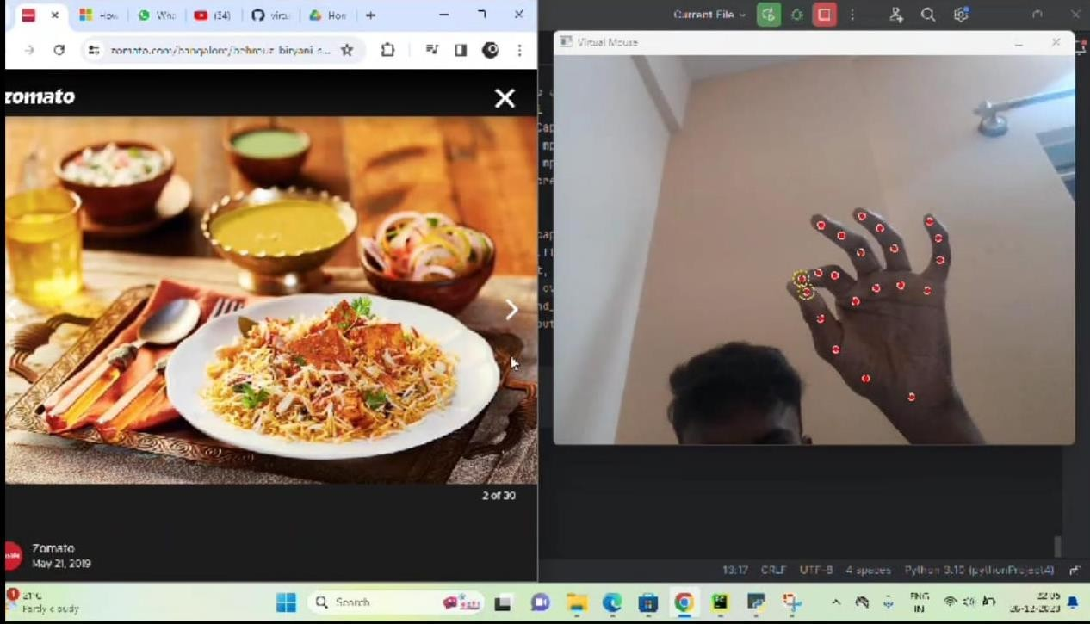

**Average accuracy of the defined AI Virtual Mouse.**

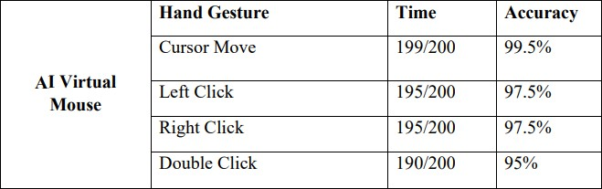

**ACCURACY:**

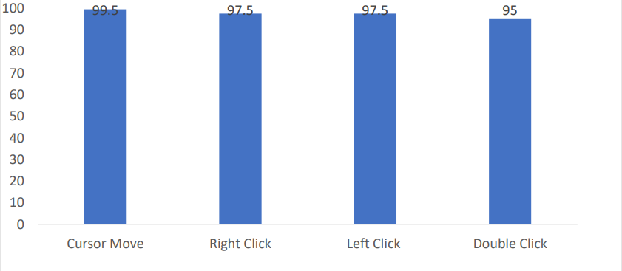

## Comparison:

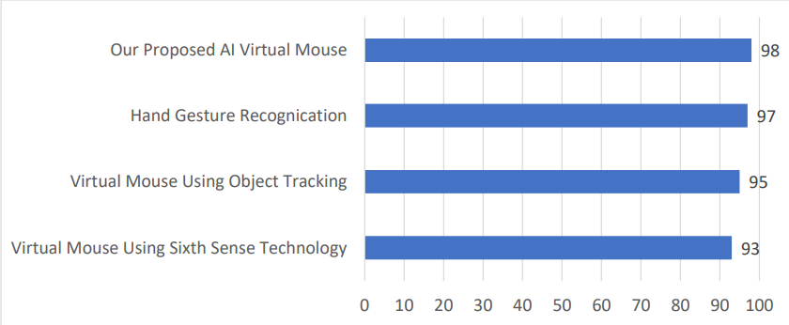

**AI VIRTUAL MOUSE WITH HAND GESTURES**

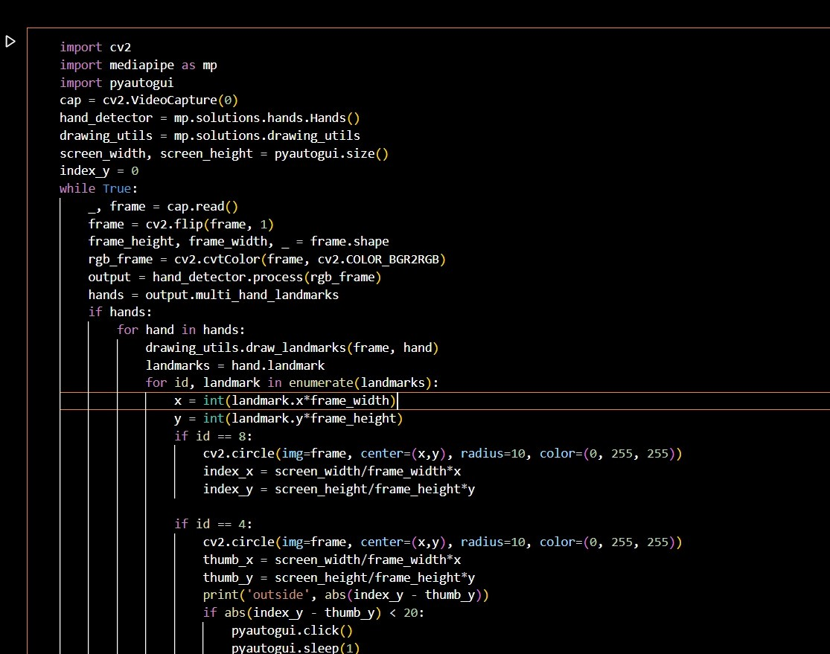

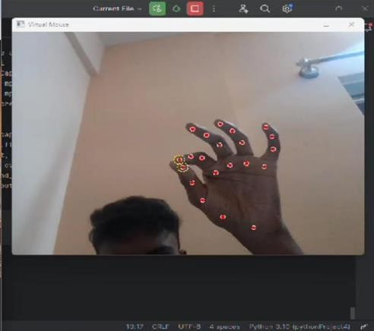

### Eye Tracking Mouse for Human Computer Interaction

The eye tracking mouse (ETM) system proposed in this mini-project aimed to address communication challenges faced by individuals with neuro-locomotor disabilities. The

system utilized a head-mounted device incorporating a webcam and video glasses, along with a novel eye tracking algorithm called ETAST (Eye Tracking with Adapted Segmentation Threshold). Unlike existing commercial systems, the ETM system presented a cost-effective and mobile solution, allowing users to control a computer mouse cursor using their eye

movements. The hardware setup involved a modified webcam on video glasses, capturing infrared images for improved pupil detection. The software, developed in C++ and C#,

employed an adaptive binary segmentation threshold algorithm to track the user's gaze and move the mouse cursor accordingly. The system underwent testing with 20 participants, yielding positive results in terms of usability, accuracy, and reliability. Despite minor

challenges related to makeup interfering with the algorithm for some participants, the ETM system received high ratings for ease of use. The authors emphasized the potential social

impact of the proposed system in facilitating the reintegration of disabled individuals into society, enabling independent communication, and improving overall quality of life. The authors also suggested future applications of the system in virtual and augmented reality,

emphasizing its potential in aiding those with limited hand functions or neuromotor paralysis.

Overall, the results indicated that the ETM system presented a promising and affordable solution for human-computer interaction in the context of assistive technology.

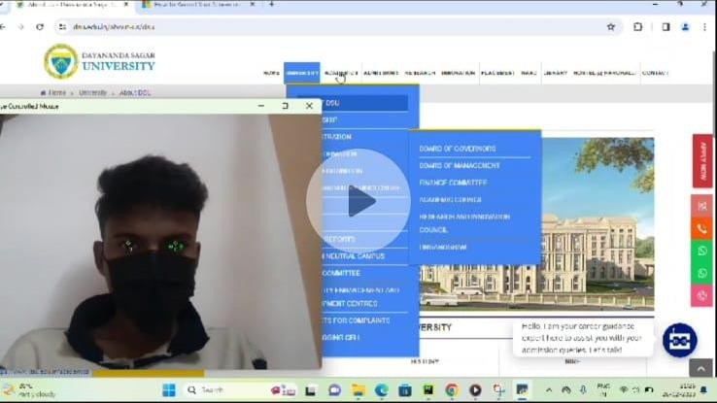

## AI VIRTUAL MOUSE WITH EYE MOVMENT

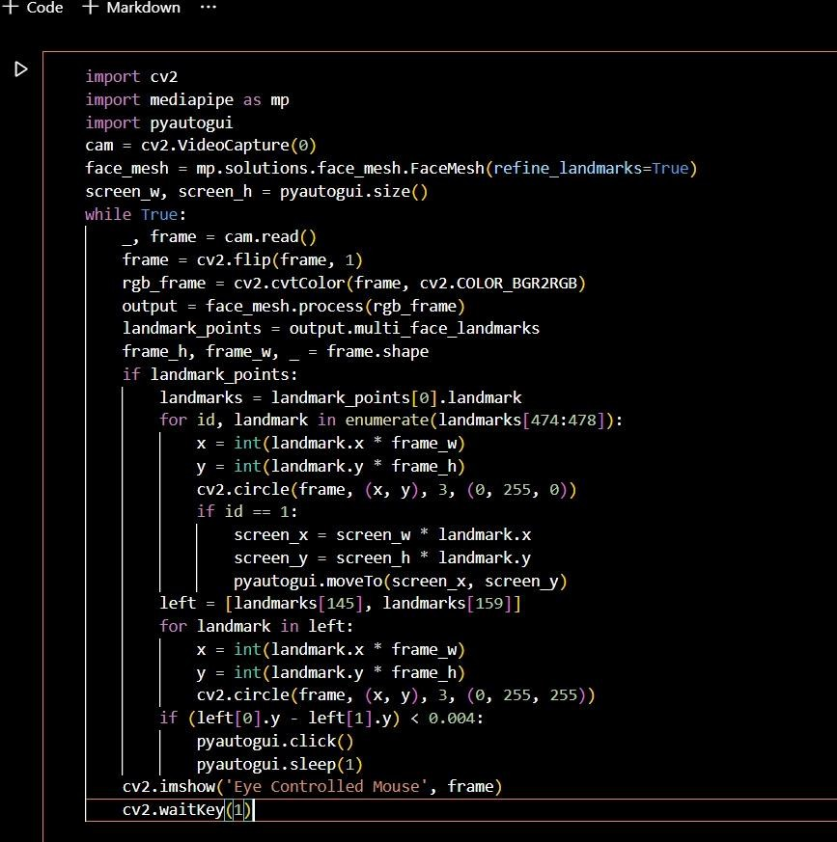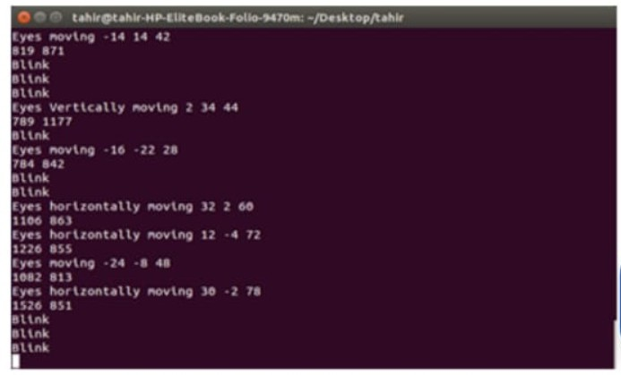

## CONCLUSION

In the Human-Computer Interfaces (HCI) field, where every mouse movement may be done with a fast of your fingertips anywhere, it should come as no surprise that the real mouse will also be overtaken by an immersive non-physical mouse and without regard to the environment, at any moment. In order to replace the common physical mouse without

sacrificing precision and efficiency, this project had to design a color recognition program.

This program can recognize color movements and combinations and translate them into

functional mouse actions. A few strategies had to be used because accuracy and efficiency are crucial factors in making the application as helpful as a real-world mouse. The primary

objective of this method is to lessen and maintain the sensitivity of the cursor by averaging the values of the colors responsible for managing cursor motions based on a set of

coordinates movements, as even a small movement could cause unintended cursor

movements. In addition, a number of color combinations were developed with the relation of distance computations between the two colors in the combination because a difference in

distance can result in a difference in the way the mouse behaves. This implementation's goal is to make it easier to control the application with minimal trouble. As a result, accurate mouse function triggering can be achieved with little trial-and-error. Moreover, calibrations phase was included to promote effective and versatile color tracking. This enables people to select their preferred colors for various mouse functions as long as the chosen colors don't

identical or comparable RGB hues (e.g. blue and sky-blue). Responsive validations were additionally developed, which essentially enables the software to save various sets of HSV levels across various angles to be utilized during the initialization step. In regards to

efficiency and lifestyle, modern technology has made significant progress in improving

society's quality of life, as opposed to the other side around. Hence, cultures must not mix while hesitantly adopting outdated technologies. The latest one is accepting revisions at the IA(HONS) Information System Engineering Department of the Institute of Information and

Communication Technology (Perak Campus), UTAR 40. Instead, it is advised that individuals accept modifications to lead a lifestyle that is more effective and productive.

## LIMITATIONS

There are number of ongoing issues in this research that could impede the outcomes of color recognition. The environment aspect when the recognition phase is taking place is one of the issues. The recognition procedure is very sensitive to brightness levels since extreme

intensity or blackness may make it impossible to see the targeted colors in the acquired

frames. In addition, distance is another issue that could have an impact on outcomes of color identification. As the current detecting zone can only allow displays of color within limited

radius. Any displays of colors beyond this limitation will be viewed as noise and filtered out.

In conclusion, the presented eye tracking mouse (ETM) system, utilizing video glasses and an adaptive binary segmentation threshold algorithm, offers a reliable, mobile, and cost-effective solution for Human-Computer Interaction (HCI) in individuals with neuro-locomotor

disabilities. The system's architecture incorporates a webcam mounted on video glasses, allowing for stable eye tracking without being affected by the user's head position. The proposed ETM method, evaluated through experiments with participants, demonstrated usability, accuracy, and reliability, earning a positive rating for ease of use. While some

challenges, such as the impact of mascara on pupil detection, were noted, the overall success of the ETM system suggests its potential for enhancing communication and independent

activities for individuals with severe neuro-locomotor handicaps. The system's affordability and adaptability make it a promising assistive technology with significant social impact, potentially aiding in the social reintegration of disabled individuals and facilitating their daily lives.

## LIMITATIONS

The presented eye tracking mouse (ETM) system described in the mini project report has notable limitations. Firstly, the system's performance is adversely affected by makeup,

particularly mascara, which interferes with the algorithm's ability to detect pupils accurately. This limitation may impact users who do not have severe neuro-locomotor disabilities.

Additionally, while the system was well-received overall, it received a lower rating from makeup professionals, highlighting a specific user group for whom the system may not be

optimal. Moreover, the report does not thoroughly address potential challenges related to the system's adaptability to diverse environmental lighting conditions, potential issues with

calibration, and the need for continuous improvements in image quality. Finally, the absence of a detailed discussion on the system's scalability and integration with other technologies

suggests a need for further exploration in these areas.

# REFERENCES

### Artificial Intelligence Virtual Mouse

* By:
  1. Alimul Rajee,
  2. Nurul ahad Farhan,
  3. Mohammad likhan,Comilla jahan.
* [https://www.researchgate.net/publication/371125547_Artificial_Intelligen](https://www.researchgate.net/publication/371125547_Artificial_Intelligence_Virtual_Mouse) [ce_Virtual_Mouse](https://www.researchgate.net/publication/371125547_Artificial_Intelligence_Virtual_Mouse)

### Eye tracking mouse for human computer interaction

* By:
  1. Robert Lupu,
  2. Florina Ungureanu,
  3. Valentin Siriteanu.
* [https://www.researchgate.net/publication/261488950_Eye_tracking_mous](https://www.researchgate.net/publication/261488950_Eye_tracking_mouse_for_human_computer_interaction) [e_for_human_computer_interaction](https://www.researchgate.net/publication/261488950_Eye_tracking_mouse_for_human_computer_interaction)